Kaya Nelson

CST – 221

Micheal Landreth

05/07/2024

GitHub Link: [Kdeshun/CST-221 (github.com)](https://github.com/Kdeshun/CST-221)

**Systems and Tools**

Performing Actions – Behind the Scenes  
Open a File:

1. The user selects a file and initiates the open command.
2. The open command sends the file location to the operating system (OS) kernel.
3. The kernel stores the file contents in memory at a specific location and passes it to the active program.
4. If the application required to open the file is not active, the kernel launches the application.
5. The application compiles the file information into classes and objects.
6. The application launches and displays the file.

Save a File:

1. The user executes the save command.
2. Active file objects are transferred out of the application and passed to the kernel.
3. The kernel references the memory locations of the file and overwrites the existing contents.
4. Once complete, the application updates to display a success message or show a save error.

Search for a File:

1. The file name is stored in a string and passed to the kernel.
2. The kernel retrieves file names from memory and stores them in an active list.
3. The kernel compares the string to each title in the list.
4. Once the file is located, the kernel passes the file location back to the active search program, which displays the file.

Launch an Application:

1. The user selects the application to launch.
2. The application launcher communicates with the kernel to retrieve all necessary file objects from memory.
3. The file objects are stored in a kernel variable and passed back to the application.
4. The launcher compiles and loads each of the application classes and then launches the app.

Display Something on the Screen:

1. The active application loads a default stage and scene.
2. The application establishes a scene object and adds text, buttons, etc., to the scene.
3. The stage is updated with the new scene, new objects, and then displayed.

**Linux / Unix proof of Instillation**

, I was able to successfully install VirtualBox and set up Ubuntu as the virtual operating system. Additionally, I installed Git and Vim on the virtual machine. As part of my progress, I created the HelloWorld.c file and saved it in the documents folder. However, when I tried to execute the file, I encountered an error and faced difficulties compiling it. Since I have limited experience running files from the console or terminal in this case, I lack the knowledge required to resolve this issue at the moment.

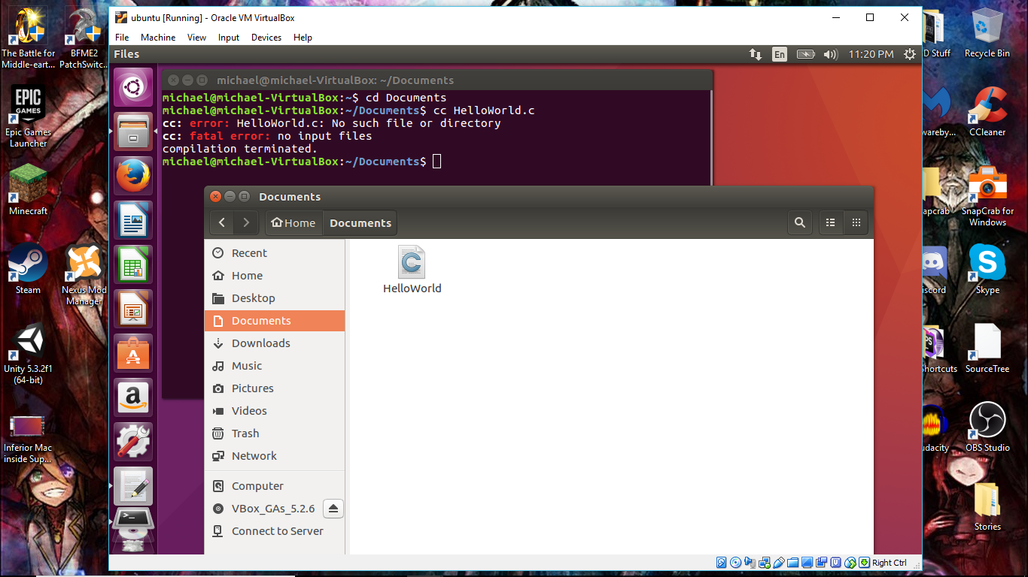

Note:  I must admit that reaching this point has been quite challenging. Learning to navigate and utilize the virtual machine while successfully installing Ubuntu has proven to be a difficult task. Additionally, I have encountered issues with accessing the shared file space that I set up for Ubuntu, making it a daunting task to transfer files between the MAC installed on my PC and the virtual machine. At one instance, I attempted to access the files created on my PC within the MAC environment, but unfortunately, I was unable to locate the folder. As a workaround, I had to resort to using the MAC to download Git and Vim, and subsequently create the necessary files directly within the virtual machine.

However, I have concerns about the feasibility of working on larger projects within this setup. The virtual machine can only allocate a limited amount of processing power, and running it strains the capabilities of my PC.

To make further progress, I would greatly benefit from the following tips:

* Setting up the ability to execute files directly from the MAC terminal.
* Successfully establishing a functional link to the shared folder, allowing seamless access to files created on the PC within the MAC environment.